**CS5551: Lab Assignment -3 (Mashup Application)**

In the present Mashup application I have used Google Charts, Twitter and Facebook API’s. I have used the Google charts API to show the contribution of various departments in the university. Also, I have used these Charts to display the number of students coming from various countries to UMKC along with the number of graduate, under graduate (UG) and Ph.D students in the School of computing and engineering. I am also attaching the jsfiddle screenshots and Opera mobile screenshots.

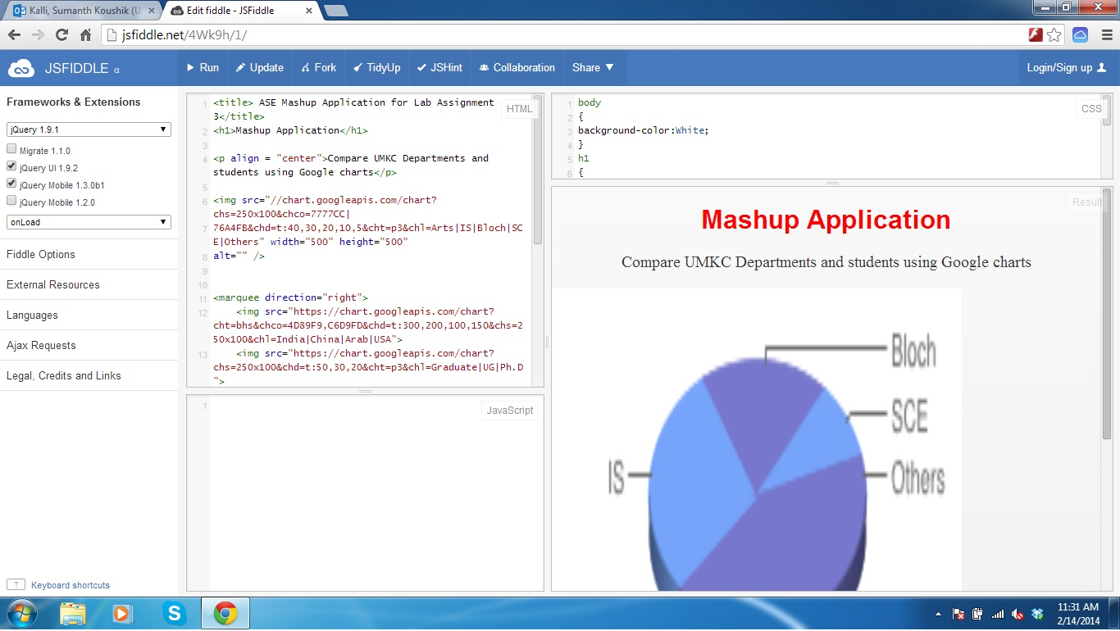

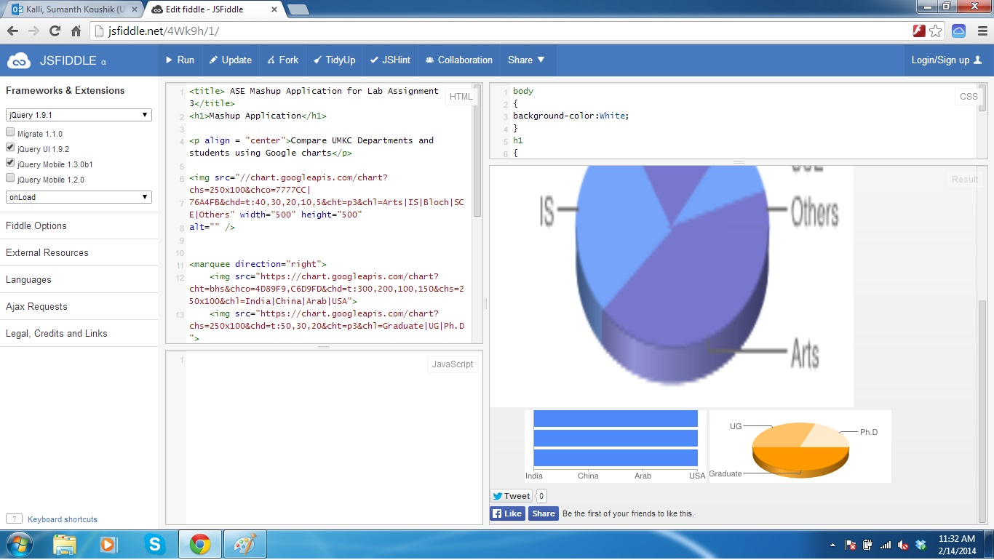

**Opera Mobile Screenshots:**

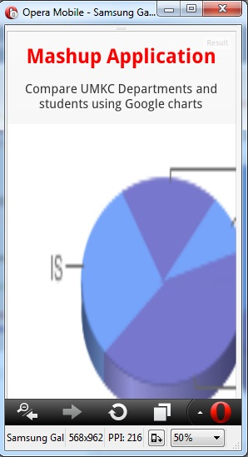

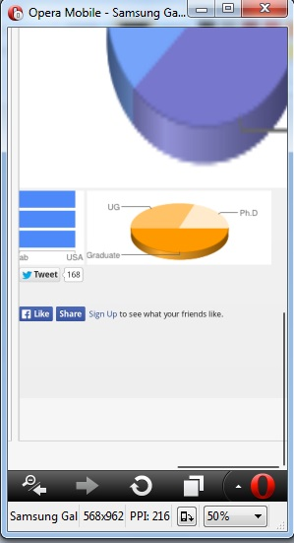

When we click on the Tweet button it automatically directs to the twitter page and gives us the option to tweet which can be seen back on any other device instantly.

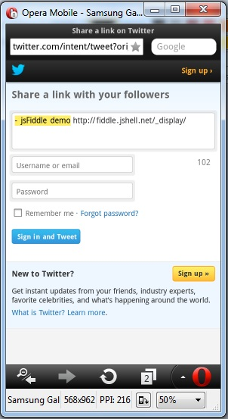

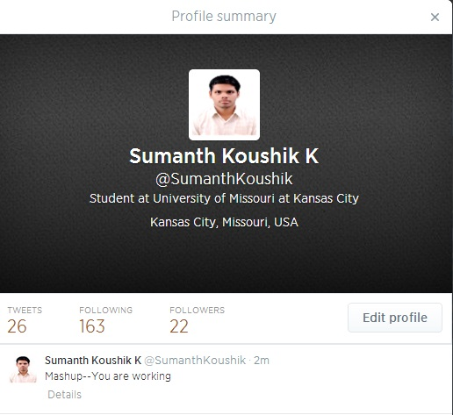

Similarly, facebook can be used as a Like and also as sharing the messages

